1. A screen shot of a computer

   Description automatically generated
2. 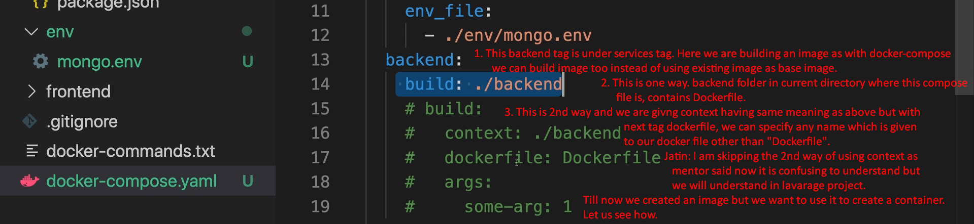  
   A screen shot of a computer

   Description automatically generated
3. A screenshot of a computer

   Description automatically generated
4. Let’s map the port  
   A screen shot of a computer program

   Description automatically generated
5. A screen shot of a computer

   Description automatically generated
6. A screen shot of a computer

   Description automatically generated
7. 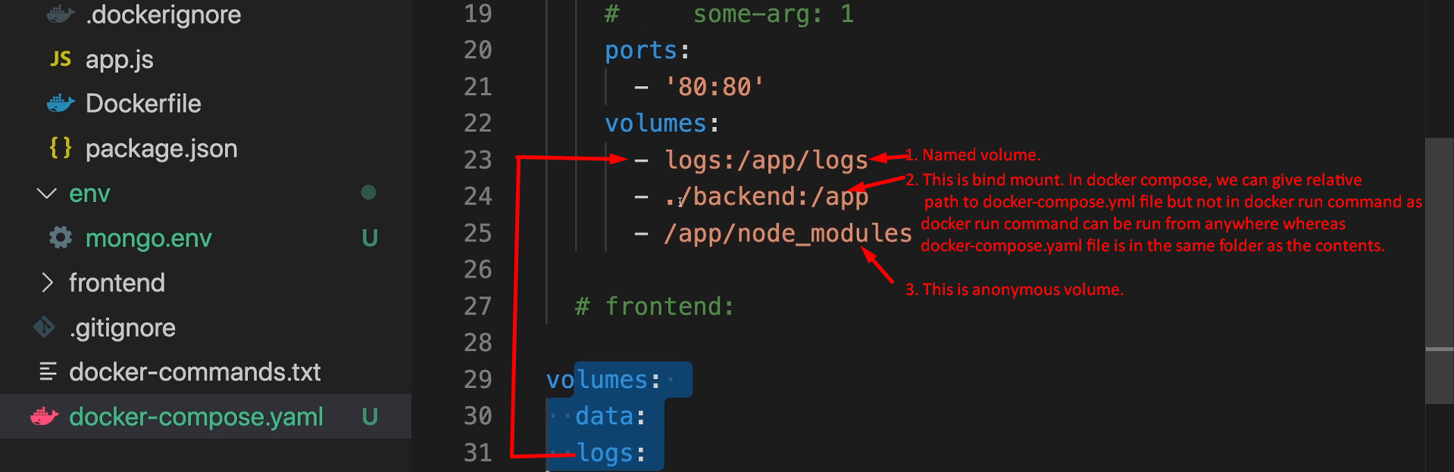
8. Let’s define environmental variables in docker-compose.yaml for backend.  
   A screenshot of a computer

   Description automatically generated  
   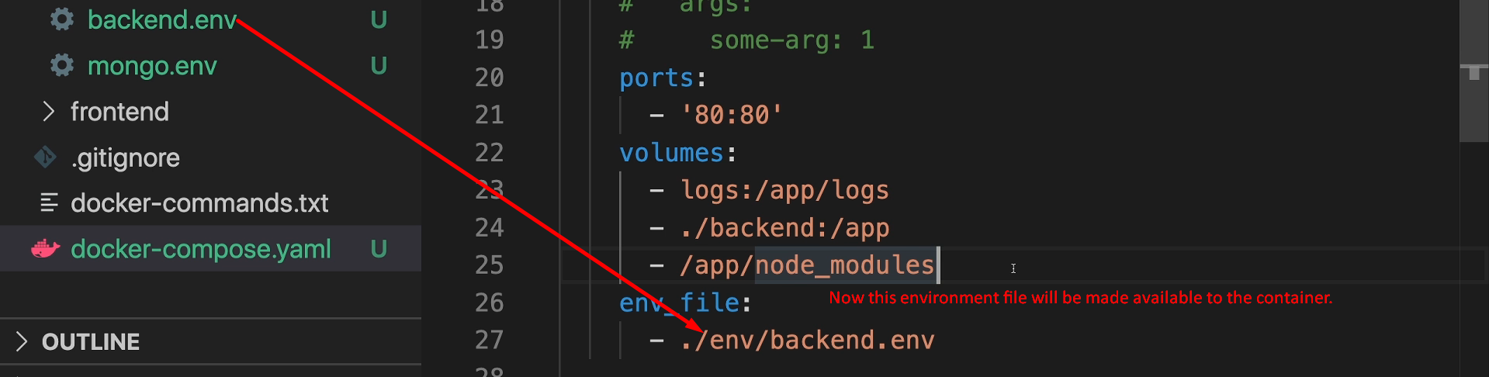
9. A screen shot of a computer program

   Description automatically generated
10. A screenshot of a computer

    Description automatically generated
11. A screenshot of a computer

    Description automatically generated  
    Above docker-complete_backend = root_directory_name_having_docker-compose.yaml + “_” + The_name_given_in_docker-compose.yaml file.  
    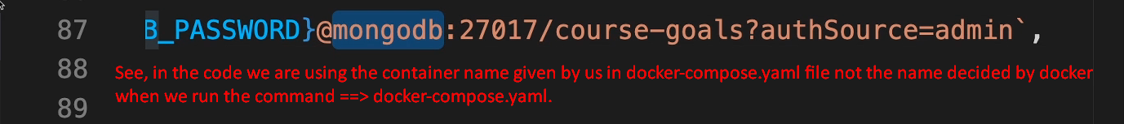
12. 
13. A screen shot of a computer

    Description automatically generated
14. Let’s work on the frontend service (container) in the next lecture.